**Software Requirements Specification**

For

**<Athlete Rehab Application + Tracker>**

Version 1.0 approved

Prepared by <Timothy Yarosh and Elena Ngo>

<Students Against Athletic Injuries>

<October 21, 2016>

Table of Contents

**Table of Contents**.........................................................................................................................ii

**1.  Introduction**.............................................................................................................................3

1.1 Purpose........................................................................................................................3

1.2  Document Conventions…...........................................................................................3

1.3  Intended Audience and Reading Suggestions............................................................3

1.4  Product Scope.............................................................................................................3

1.5  References..................................................................................................................3

**2.   Overall Description**.................................................................................................................4

2.1  Product Perspective ....................................................................................................4

2.2  Product Functions........................................................................................................4

2.3  User Classes and Characteristics..............................................................................10

2.4  Operating Environment..............................................................................................10

2.5  User Documentation...................................................................................................10

2.6  Assumptions and Dependencies................................................................................10

**3.   External Interface Requirements**.........................................................................................10

3.1  User Interfaces...........................................................................................................10

3.2  Software Interfaces.....................................................................................................11

3.3  Communications Interfaces........................................................................................11

**4.   System Features**...................................................................................................................12

4.1 Injury Report Form......................................................................................................12

4.2 Report History/List.......................................................................................................12

4.3 Create Plan/Tracker.....................................................................................................13

4.4 Registration System....................................................................................................13

**5.   Other Nonfunctional Requirements**....................................................................................14

5.1  Safety Requirements..................................................................................................14

5.2  Security Requirements............................................................................................. 14

5.3  Software Quality Attributes.........................................................................................14

5.4  Business Rules...........................................................................................................15

**Appendix A: Glossary**................................................................................................................15

**Appendix B: Analysis Models**...................................................................................................16

**1.** **Introduction**

**1.1** **Purpose**

The purpose of this document is to express the Athlete Rehab Application in greater detail. It will explain the structure of this system such as the, requirements,  functions, interfaces, and design.

**1.2** **Document Conventions**

Text that are bolded are the words that are regarded. For readers, it makes them more easier to spot.

**1.3** **Intended Audience and Reading Suggestions**

This document is intended for the Software Engineering class, **CS275** along with the professor. They can be the testers for this program. This document is also for the student athletes and trainers who are going to use the system. For this audience, reading the **overall description** (which includes the Use Case diagram) and then the **external interface requirements** would help them understand the structure and functionality of the system better.

**1.4** **Product Scope**

This software application is a system that records an athlete’s injury description, that an athlete inputs into the system. It is useful for athletes who want to check in and deal with their injuries right away. Without this system, they would have to wait the next day for their injuries to be diagnosed by their athletic trainer. This system helps perform some of the work for the trainer if the trainer is not available. The system also gives the trainer the ability to give daily treatment options to the athlete.

**1.5** **References**

In working together with the athletic training staff here at Ursinus, we plan to get the most reliable information directly from the people who work with athletes on a daily basis.

Supplemental Resources:

Pennsylvania Athletic Trainers' Society. *Forms & Downloads: Pennsylvania Athletic Trainers' Society*. 2012. 31 October 2016. <http://www.gopats.org/members/forms-downloads.htm>.

**2.** **Overall Description**

**2.1** **Product Perspective**

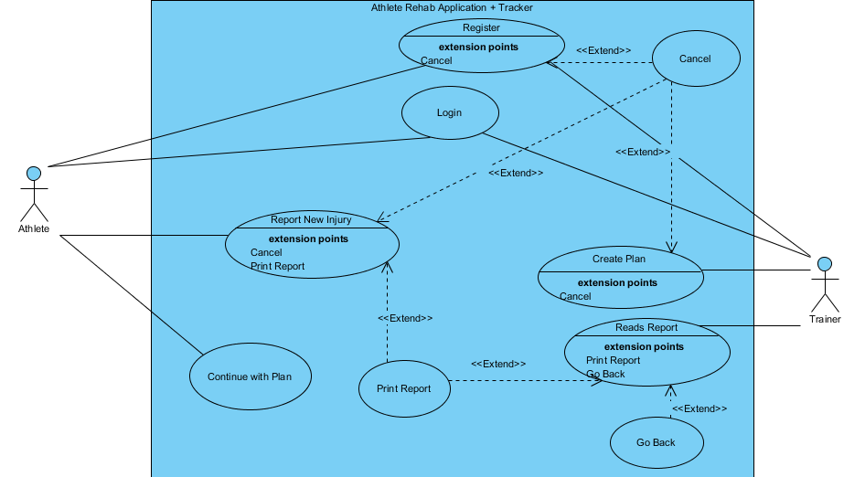

**Figure 1 - System in Use Case Diagram**

The Athlete Rehab Application operates in a Windows or IOS machine. The athlete and trainer can access the system from a computer. Only the trainer is allowed to access the list of reports in the system.

**2.2** **Product Functions**

To describe the product functions more specifically, this section will describe the components of the Use Case Diagram (Figure 1) that is shown in section 2.1, in a **textual description**.

**Use Cases:**

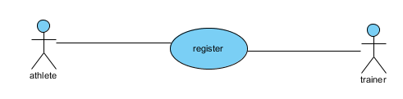

The Athlete and Trainer create their account in the system by registering.

**Use Case Name:** Register

**Participating Actors:** Athlete, Trainer

**Entry Condition:** Athlete or Trainer is in front of the system where they are able to touch it and they click on the “Register” button

**Exit Condition:** Athlete or Trainer submits their registration

**Flow of Events:**

1.       Athlete or Trainer clicks on “Register”

2.       Athlete or Trainer enters their name

3.       Athlete or Trainer enters a password

4.     Athlete or Trainer enters an email

5.     For Athletes, they must enter their year of graduation and the sport(s) they play.

6.     Athlete or Trainer clicks on “Submit”

7.     System stores their account registration data

**Special Requirements:** None

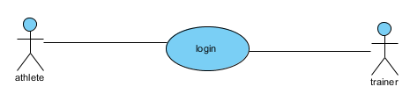

The Athlete or Trainer logs in to the system.

**Use Case Name:** Login

**Participating Actors:** Athlete, Trainer

**Entry Condition:** Athlete or Trainer is in front of the system where they are able to touch it.

**Exit Condition:** Athlete or Trainer clicks on “Login”

**Flow of Events:**

1.       Athlete or Trainer enters their username

2.     Athlete or Trainer enters their password

3.     Athlete or Trainer clicks on “Login”

**Special Requirements:** Athlete or Trainer must have already registered into the system

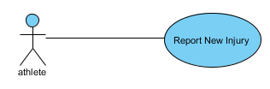

Athlete submits a new injury report

**Use Case Name:** Report New Injury

**Participating Actors:** Athlete

**Entry Condition:** Athlete has logged in and selected “Report New Injury”

**Exit Condition:** Athlete submits and confirms their injury report

**Flow of Events:**

1.       Athlete selected “Report New Injury”

2.       Athlete selected where their injury is located

3.     Athlete selected when and how the injury occurred

4.     Athlete describes their injury

5.     Athlete selects the intensity of that injury on a scale of 1-10

6.     Athlete clicks on “Submit”

7.     Athlete reads what they inputted

8.     Athlete confirms their input

**Special Requirements:** None

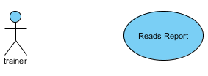

The trainer reads the report the that athletes had already submitted

**Use Case Name:** Reads Report

**Participating Actors:** Trainer

**Entry Condition:** Trainer has logged in and selected “See Reports”

**Exit Condition:** Trainer selects “Create Plan”

**Flow of Events:**

1.       Trainer logs in

2.       Trainer selected “See Reports”

3.       Trainer selects an athlete to see reports from

4.     Trainer reads the report

5.     Trainer selects  “Create Plan”

**Special Requirements:** None

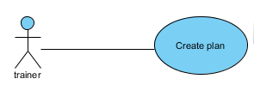

Trainer creates a treatment plan for the injured athlete

**Use Case Name:** Create Plan

**Participating Actors:** Trainer

**Entry Condition:** Trainer is looking at an athlete’s injury report and clicks on “Create Plan”

**Exit Condition:** Trainer submitted the “Plan”

**Flow of Events:**

1.       Trainer clicks on “Create Plan”

2.       Trainer enters what the treatment plan is

3.     Trainer enters what the athlete should do for that plan

4.     Trainer clicks on “Submit”

**Special Requirements:** None

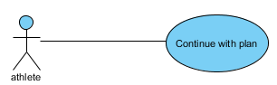

Athlete decides to track and continue their treatment plan

**Use Case Name:** Continue with Plan

**Participating Actors:** Athlete

**Entry Condition:** Athlete has logged in and selects “Continue with Plan”

**Exit Condition:** Athlete “Exits”

**Flow of Events:**

1.       Athlete selects “Continue with Plan”

2.       Athlete checks off that they have done their plan for today

3.     Athlete tracks their plan

4.       Athlete clicks on “exit”

**Special Requirements:** None

**Extensions:**

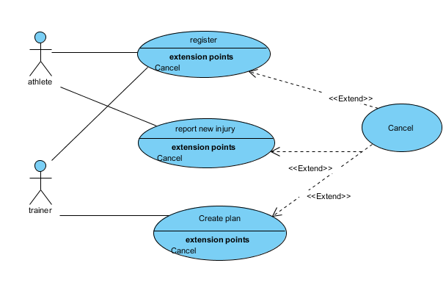

**Extension Use Case:** Cancel

Cancel extends the Register, Report New Injury, and Create Plan use cases

**Participating Actors:** Athlete, Trainer

**Entry Condition:** Athlete or Trainer is in the process of registering in the system/Athlete is in the process of reporting their injury/ Trainer is in the process of creating a plan for the athlete.

**Exit Condition:** Athlete or Trainer clicks on “Cancel”

**Flow of Events:**

1.       Athlete or Trainer decides to cancel on whatever process they’re in that has the “Cancel” extension.

2.     Athlete or Trainer clicks on “Cancel”

**Special Requirements:** None

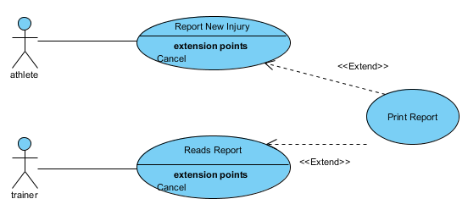

**Extension Use Case:** Print Report

Print Report extends the Report New Injury and Reads Report use cases.

**Participating Actors:** Athlete, Trainer

**Entry Condition:** Athlete has submitted their report/ Trainer is looking at an injury report.

**Exit Condition:** Athlete or Trainer has printed the report

**Flow of Events:**

1.       For Athlete: Once they confirmed their report, they have the option to print their report.

2.       For Trainer: While they are reading an athlete’s report they have the option to print their report.

3.     Athlete or Trainer clicks on “Print Report”

4.     Athlete or Trainer printed the report.

**Special Requirements:** None

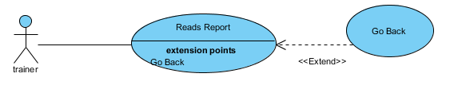

**Extension Use Case:** Go Back

Trainer has the option to not create a plan while reading the report

**Participating Actors:** Trainer

**Entry Condition:** Trainer is looking at an athlete’s report

**Exit Condition:** Athlete clicks on “Go Back”

**Flow of Events**:

1. Trainer is looking at an athlete’s report
2. Athlete clicks on “Go Back”

**Special Requirements:** None

**2.3  User Classes and Characteristics**

The Athlete is expected to be injured or in pain somehow when using the system. They are also expected to describe their injury. The Trainer is expected to be able to read and understand the reports stored and listed in the system. The Trainer is also expected to know what daily treatment treatment advice to give to the athlete.

**2.4**  **Operating Environment**

This software will operate on a computer platform such as Windows and IOS.

**2.5**  **User Documentation**

There will be a simple How-To manual for the system and a Javadoc for the system’s code.

**2.6**  **Assumptions and Dependencies**

This software depends on the user being able to enter all of the necessary information required in order for our application to accurately target the cause of injury. The application as a whole depends on the functionality of receiving input, storing it, and outputting it if the user chooses to do so. Another dependency the system has is the reliability of the user interface. The interface must clearly be displayed upon each use of the application. We will assume that the user has sustained one of four common athletic injuries and can accurately describe where and how they sustained the injury. We will also assume that the user has not had the chance to see an athletic trainer prior to using our application as the purpose of our system is to help athletes try and figure out what kind of injury they may have.

**3.** **External Interface Requirements**

**3.1** **User Interfaces**

Since this application will be in a GUI, here is a sample design (a prototype) of what it should look like:

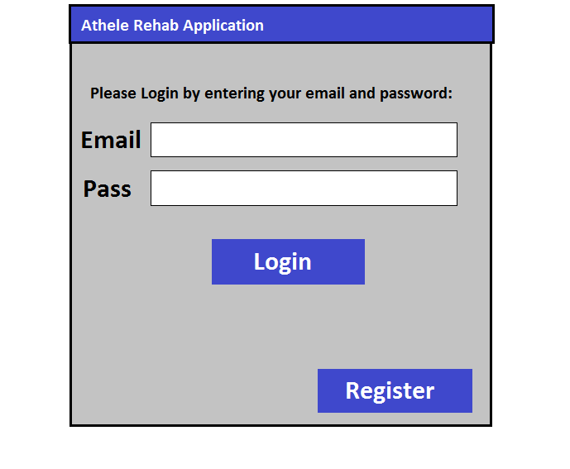

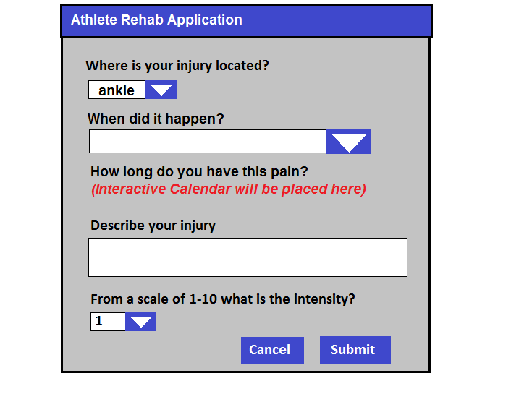

There will be text boxes for athletes to enter their names and for describing their injuries. There will also be text boxes for entering emails and passwords. The drop boxes are there to provide specific choices for users to chose from so that the system can understand the input better. Buttons are usually at the bottom for user to click on when they are finished.

**3.2** **Software Interfaces**

This product doesn’t have any connections with other software components. It’s a system that stores its own data, that comes from the athlete’s or trainer’s input.

**3.3** **Communications Interfaces**

This system doesn’t connect with any outside communication interfaces other than connecting to the registered user’s email, because the log in requires the user to enter their email and their password.

**4.** **System Features**

This section will express the specific features that the system will have.

**4.1** **Injury Report Form**

**4.1.1 Description and Priority:**

The injury report form is apparently a electronic form for athletes to fill out by describing their injury and submitting it in order to receive help. This feature is high priority because the purpose of this application is to help injured athletes. Benefit 10, penalty 7.

**4.1.2 Stimulus/Response Sequences:**

The series of actions the user (an athlete) will follow in order to successfully use this form in the application include:

1. Choosing from a list of body parts where they think their injury occurred.
2. Indicate how long they have been experiencing pain in the area chosen in the previous step.
3. Give a brief description of their injury.
4. Rate how painful their injury is at the moment of them filling out the form.

**4.1.3 Functional Requirements**

REQ-1: This form in the application shall be able to run on a laptop regardless of whether it is a Windows or IOS machine.

REQ-2: This form shall be able to receive input from the athlete(i.e. brief description of the injury, date injury occurred, pain rating).

REQ-3: This form shall be able to generate an athlete’s injury report.

REQ-4: This form shall be able to be used by any athlete.

REQ-5: The system shall be able to keep a record of all of the injury reports.

REQ-6: The system shall be able to prevent the athlete from submitting an injury report if the report is incomplete .

**4.2 Report History/List**

**4.2.1 Description and Priority:**

The application will keep a list of all the athletes who have used the system and had it generate an injury report. This feature is a high priority because it is essential for an athletic trainer to be able to view a specific athletes report. Benefit 9, penalty 6.

**4.2.2 Stimulus/Response Sequences:**

The series of actions the system and the user will take in order to generate an injury report include:

1. The user/athlete selects that they want an injury report generated.
2. The system takes all the info the user inputted and formats it into a user friendly format.
3. The system returns the formatted injury report.
4. All of the reports will be stored in a list.

**4.2.3 Functional Requirements**

REQ-1: The system shall be able to be used by any athletic trainer.

REQ-2: The system shall be able to let the trainer access the input/report history.

REQ-3: The system shall be able to give a disclaimer to the user.

REQ-4: The system shall prevent an athlete from looking at another athlete’s report.

**4.3 Create Plan/Tracker**

**4.3.1 Description and Priority:**

The application will be able to allow the user to access their report on a daily basis and use it as a method for tracking their recovery process. This feature is a medium/high priority because some injuries may not require daily updates as to how the recovery process is going, while other injuries are more severe and the daily updates are necessary to the overall recovery process. Benefit 7, penalty 5.

**4.3.2 Stimulus/Response Sequences:**

The series of actions the system will take in order to create a plan for the user to use to track their progress include:

1. Using the current date gotten from the system to determine if a user checks into the system each day they are supposed to.
2. Will offer the user check boxes or similar functionality to let the user verify that they completed the rehab they were supposed to do on a given day.
3. Will let the user know when all the required steps of rehab are completed for that day.

**4.3.3 Functional Requirements**

REQ-1: The system shall let the Trainer create a Plan for the Athlete.

REQ-2: The system shall be able to allow the user to track their progress daily.

REQ-3+: TBD

**4.4 Registration System**

**4.3.1 Description and Priority:**

This system allow trainers and athletes to register into the system so that they can log in and perform any actions they want to do in that system depending on whether or not they are a trainer or an athlete. Only users that registered in the system are able to use the system. This is of high priority because without the registration system, it’ll be hard for the system to identify whether or not the user is a trainer or an athlete. This is essentially for security purposes. Benefit 9, penalty 9

**4.3.2 Stimulus/Response Sequences:**

The series of actions the system and the user will take in order for the user to register into the system include:

1. The system giving the user an option to register
2. The system asking the user for name, occupation (athlete or trainer), email and password during the registration process.
3. The system storing what the user input into a list
4. The system using the list to identify the user if the user tries to log in
5. The login will ask for email and password.

**4.3.3 Functional Requirements**

REQ-1: The system shall let the user register.

REQ-2: The system shall identify registered users.

REQ-3: The system shall let registered users log in.

**5.** **Other Nonfunctional Requirements**

**5.1** **Safety Requirements**

Note that rebooting the system may result in loss of report data, in other words the recorded list of reports will clear up. There is no specific concern that the system will physically harm the users. Therefore there system is considered to be physically harmless. However if the system does any harm to the athlete and trainer in any rare case, contact the local safety department.

**5.2** **Security Requirements**

The registration system is there to identify whether or not the user is an athlete or a trainer. If the user registered as an athlete, the only things they can do in the system are reporting a new injury and tracking their treatment plan. If the user registered as a trainer, the only things that they can do in the system are looking at the list of reports and creating a plan for a specific injured athlete. Therefore, an athlete should not be able to see the report of another athlete. Any attempt by an athlete to view another athlete’s report will be blocked by the system. However, the athletic trainer will have access to all of their athletes reports. A specific athlete’s report should be able to be returned based on the athlete's information that they inputted into the system. That information can then be accessed via their name or some other key which has yet to be determined. In order for the system to identify if a trainer is using the system, the trainer should register and identify themselves as a trainer in the system.

**5.3** **Software Quality Attributes**

This software will help athletes because without this system, they would have to wait the next day for their injuries to be diagnosed by their athletic trainer. This system helps perform some of the work for the trainer if the trainer is not available. This immediate feedback will lead to more efficient treatment plans and quicker recovery times so athletes can get back on the field sooner. Plus the system will lead to greater transparency between athletic trainer and athlete and mitigate the number of hoops either party needs to jump through in order to receive the best treatment. The ultimate goal would be to minimize the number of days lost due to injury and the recovery time associated with the injury sustained. This would lead to more players in practice and more importantly in games throughout the long season.

**5.4** **Business Rules**

In this system, if an athlete is injured or has reason to believe that they sustained an injury, then they will be able to use the system. In addition, an athletic trainer will be able to use this system as a way to keep up with the number of athletes who have injuries that need to be addressed.

**Appendix A: Glossary**

**Extensions -** When one use case depends on another use case. Usually extension use cases are optional choices that the users make in the system.

**GUI -** Graphical User Interface. Where the user interface is displayed in a graphic and visual way.

**CS275 -** Refers to Software Engineering course via its course ID.

**Textual Description -** Description of the use cases in the use case diagram. It includes its name, Entry Condition, Exit Condition, Flow of Events, and Special Requirements.

**Entry Condition -**A condition that needs to be met to make the use case happen.

**Exit Condition-** A condition that needs to be met to order to get out of the use case.

**Flow of Events-** A series of events that will happen between the user and the system during the use case.

**Special Requirements-** A different requirement that needs to be met before the use case can happen.

**Plan-** A treatment plan that lets Athletes treat their injury from time to time and track it.

**Appendix B: Analysis Models**

**Use Case Diagram:**

